Medical Reserve Corps
MRC Regional Deployment Protocols
Deploying Volunteers within MA Public Health
Emergency Preparedness Region II



Table of Contents
Established March 2014
Updated November 2022

Map of MRCs within Region II ………………………………………………….2
Greater Grafton MRC Deployment Protocol……………………………3-4
Wachusett MRC Deployment Protocol……………………………………5-6
Worcester Regional MRC………………………….……………………………7-8
Volunteer Roles……………...………………………………………………………...9
Volunteer Request Form….……………………………………………………...10

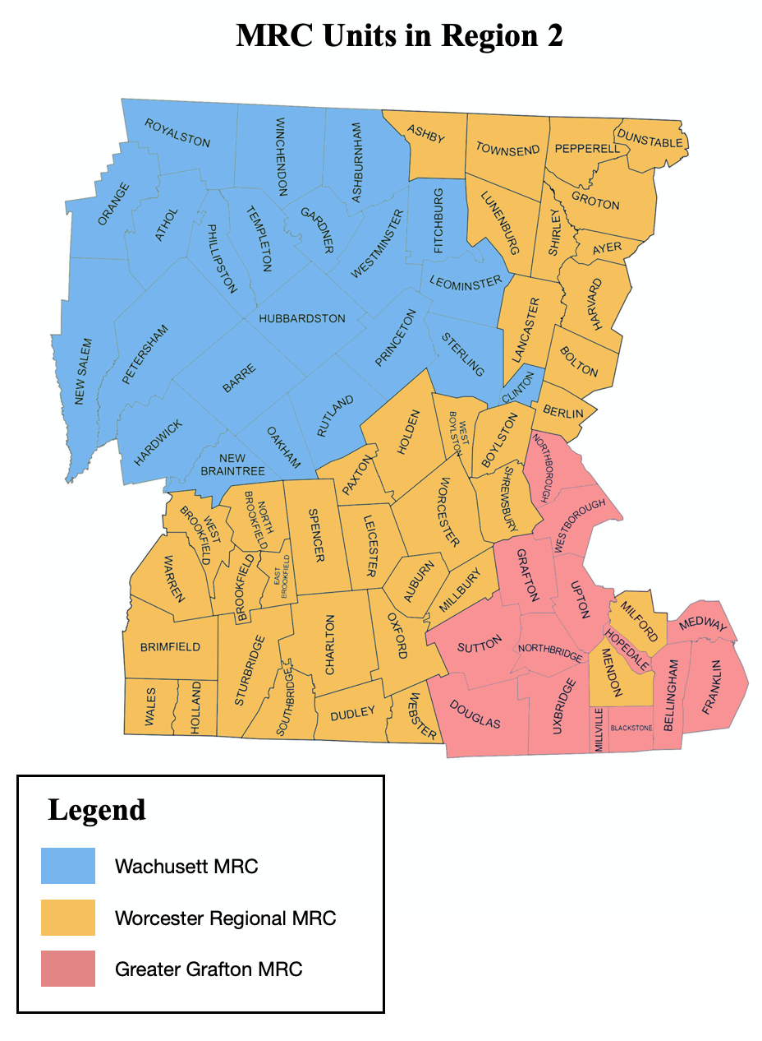
Unit Leaders

Wachusett MRC Coordinator Judie O’Donnell (501c3)
Greater Grafton MRC Coordinator Marianne DeVries (Grafton Police)
WRMRC Coordinator Lois Luniewicz (Worcester DPH)

*Please see individual MRC deployment protocol for town listing.

TOWN OF GRAFTON


28 PROVIDENCE ROAD
GRAFTON, MA 01519
GREATER GRAFTON MEDICAL RESERVE CORPS

E-mail: devriesm@grafton-ma.gov

Greater Grafton Medical Reserve Corps
Protocol for Request and Deployment of Volunteers
Emergency and Non-Emergency Requests

Bellingham Blackstone Douglas Franklin Grafton Hopedale Medway Millville
Northbridge Northborough Sutton Westborough Upton Uxbridge

Marianne DeVries, Coordinator
Devriesm@grafton-ma.gov
508-864-5923, Cell
Alternate Contact: Evan Brassard, brassarde@grafton-ma.gov, 413-351-1671, Cell
Policy:
The purpose of the Greater Grafton Medical Reserve Corps is to assist with and provide community support for emergency or non-emergency situations in the fourteen communities listed above that are covered by the unit.

The Greater Grafton Medical Reserve Corps (GGMRC) is not a first responder organization and it is not within GGMRC capability to respond within minutes of an event. Although there may be circumstances when a rapid response is needed, the GGMRC must first send out a volunteer notification in order to coordinate a response. It is our goal to provide support in the first few hours of an event upon request.
Procedure:
- Representative from community’s health department /Central Mass Regional Public Health Alliance, emergency management or other authorized person contacts MRC Coordinator or Administrative Assistant if Coordinator not available.
- Information that should be gathered by requestor before contact (see attached request form).
- Date and time needed
- Requestor’s name and title
- Address/Location of event
- Point of Contact at event
- Type of Event
- Volunteer Info
- Type of volunteers needed (medical/non-medical)
- How many of each
- Professions and skills needed
- Duration of Shift (s)
- Additional info (meals, supplies, lodging, transportation, parking etc)
- Directions
- Coordinator will contact members through the MA Responds system or other determined means if necessary and report back to requestor ASAP in the case of an emergency or at a designated date and time for a community event.
- If for any reason the GGMRC is unable to provide enough support, the coordinator will then reach out to other MRC units within Region II.
- Other Region 2 MRC Coordinators or their designees should follow same procedure to request assistance. If the ESF-8 desk is activated, the state protocol should be followed.

Last Revised November 2022


Wachusett Medical Reserve Corps
Deployment Protocol
Emergency and Non-Emergency Requests
Reviewed and Updated 2022

Ashburnham Athol Barre Clinton Fitchburg Gardner Hardwick Hubbardston Leominster New Braintree New Salem Oakham Orange Petersham Phillipston Princeton Royalston Rutland Sterling Templeton Westminster Winchendon

Policy:
The purpose of the Wachusett Medical Reserve Corps is to assist with and provide community support for emergency or non-emergency situations in north Worcester County.

Procedure:
- A representative from the community’s health department, emergency management team or other authorized person will contact an Officer of the Wachusett MRC (see below) to request volunteer help.
- Information to be provided with the request:
A. Date and time needed
B. Requestor’s name and title
C. Address/Location of event
D. Point of Contact at event
E. Type of Event
F. Volunteer Info (see attached request form)
- Type of volunteers needed (medical/non-medical)
- How many of each
- Professions and skills needed
- Duration of Shift (s)
- Additional info (meals, supplies, lodging, transportation, parking etc)
- Directions
- The contacted Officer will request Wachusett MRC members through appropriate means determined by the request which can include but not be exclusive to phone, email, social media or the MAResponds system contact methods. Wachusett will report back to the requestor as soon as possible in the case of an emergency or at a designated date and time for a community event.
- Other Region 2 MRC Coordinators or their designees will follow similar procedures for requests of assistance. If the ESF-8 desk is activated, the state protocol should be followed.

Officers

Judith O’Donnell RN MPH
WMRC Coordinator/President
P.O. Box 555
Hubbardston, Ma 01452
wachusettmrc@gmail.com
Home 978-928-4086
Office 978-928-3834
Cell 978-270-9935

PJ Taucer M.Ed
Vice President
Cell: 508-847-0093
Work: 508-616-2822

Dennis O’Donnell
Secretary/Treasurer
Home 978-928-4086
Cell 978-270-9934

Last Revised November 2022


Worcester Regional Medical Reserve Corps
(WRMRC)

Ashby Auburn Ayer Berlin Bolton Boylston Brimfield Brookfield Charlton Dudley Dunstable East Brookfield Groton Harvard Holden Holland Lancaster Leicester Lunenburg Mendon Milford Millbury North Brookfield Oxford Paxton Pepperell Shirley Shrewsbury Spencer Southbridge Sturbridge Townsend Wales Warren Webster West Boylston West Brookfield Worcester

Deployment Protocol - Emergency and Non-Emergency Requests
Policy:
The mission of the Worcester Regional MRC is to provide medical and non-medical volunteer services to cities and towns in Central MA (Public Health Region 2) to supplement existing resources in the case of disasters or in non-emergency situations.
The Worcester Regional MRC (WRMRC) is not a first responder organization, and it is not within WRMRC capability to respond within minutes of an event. Although there may be circumstances when a rapid response is needed, the WRMRC must first send out a volunteer notification to coordinate a response. It is our goal to provide support in the first few hours of an event upon request.

Procedure:
- A representative from a community’s health department, emergency management team or other authorized person will contact Lois Luniewicz (508-450-4226) or one of her alternates listed in order below with a request for volunteers.
  - Please include (see attached request form):
    - Date(s) and time(s) needed
    - Requestor’s name and title
    - Address/Location of event or requested response
    - Point(s) of Contact at deployment site
    - Type of Event
    - Volunteer Info
    - Type of volunteers needed (medical/non-medical)
    - Number of each needed
    - Professions and skills/specified training needed
    - Duration of Shift(s)
    - Number of anticipated shifts
    - Length of each anticipated shift
    - Additional info (meals, supplies , lodging, transportation, parking etc)
  - Directions
  - Condition of access roads
  - Will special clearance be needed for entry
- Coordinator will contact volunteers through the MA Responds system or other determined means if necessary and report back to requestor as soon as possible in the case of an emergency or at a designated date and time for a community event.
- If for any reason the WRMRC is unable to provide enough support, the coordinator will then reach out to other MRC units within Region II.
- If support is needed beyond Region II, the WRMRC will follow State protocol for requesting MRC volunteers beyond this jurisdiction.

Primary Contact
Lois Luniewicz, WRMRC Coordinator
Loisluniewicz@comcast.net
Office, Cell: 508-450-4226
Home: 978-874-2858

Alternate Contacts
Pamela Masters, Region 2
HMCC Program Manager
mastersp@worcesterma.gov
Cell: 508-450-4734

Shane Keville-Wagner, Region 2
HMCC Planning and Ops. Coordinator
Kevlle-wagners@worcesterma.gov
Office: 508-799-8531 X33167
Cell: 508-735-3087

Alissa Errede, Region 2 HMCC
Chief, Office of Health & Medical Preparedness
ErredeA@worcesterma.gov
Office: 508-799-8531 x 33158
Cell: 508-439-1195

Last Revised November 2022

MRC ROLES 2022:
- 1st Aid, CPR/AED, STOP THE BLEED providers/trainers
- For COVID19, Flu or other vaccination sites as well as other medical events: Greeters, registration, flow coordinators, runners, vaccinators, observers
- Contact Tracers
- Provide Health and other relevant information at health or other fairs, polling places, schools
- Administrative or documentation support: health departments, public health, and school nurses
- Trainers: Emergency Dispensing sites, shelter support
- Supply, logistics management
- Translators/interpreters
- Drivers: Meals on Wheels, flyer distribution, EDS/Emergency Supplies
- Amateur radio operations (NO ESTABLISHED TEAM)
- TASK FORCES: Trailer (Existing); other teams under discussion
- Support for, working with: Local CERT and other Emergency Preparedness/Response TEAMS
- PARTICIPATE IN Exercises/DRILLS AS players/actors/evaluators
- Staffing/support for emergency, warming/cooling shelters; Volunteer Reception Areas, call centers
- Also….we are open to suggestions. Our volunteers want to participate so if you have an idea, we are listening!

